Case Study Report



**Tech Saksham**

Data Analytics with Power BI

**“SUPPLY CHAIN ANALYSIS OF INVENTORIES”**

**“GOVERNMENT ARTS COLLEGE IN DHARMAPURI”**

|  |  |
| --- | --- |
| **NM ID** | **NAME** |
| **5851661447ACE278C514483EDF6463D8** | **M.KOKILA** |

|  |  |
| --- | --- |
|  |  |
|  | Trainer Name : R.UMAMAHESWARI |
|  | Master Trainer :R.UMAMAHESWARI |

**ABSTRACT**

In the digital age, data has become an invaluable asset for businesses, particularly in the chain analysis. The proposed project, “Supply Chain Analysis of Inventories,” aims to leverage PowerBI, a leading business intelligence tool, to analyze and visualize chain analysis data. This project will enable products to gain deep insights into customer behavior, preferences, and trends, thereby facilitating data-driven decision-making and enhancing customer satisfaction. The chain analysis of inventories will allow products to respond promptly to changes in customer behavior or preferences, identify opportunities for discounts and product unit price, and tailor their products and services to meet customer needs. The project will also contribute JIT,VMI, and DRP developed for inventory management will be introduced.

**INDEX**

|  |  |  |
| --- | --- | --- |
| **Sr. No.** | **Table of Contents** | **Page No.** |
| 1 | Chapter 1: Introduction | 4 |
| 2 | Chapter 2: Supply Chain Operations : Planning and sourcing | 6 |
| 3 | Chapter 3: Supply Chain Operations : Making and Delivering | 7 |
| 4 | Chapter 4: Metrics for Measuring Supply Chain Performance | 9 |
| 5 | Conclusion | 18 |
| 6 | Future Scope | 19 |
| 7 | References | 20 |
| 8 | Links | 21 |

**CHAPTER 1**

**INTRODUCTION**

* 1. **Problem Statement**

Appreciate What a supply chain is and what it does. Understand where your company fits in the supply chains it participates in and the role it plays in those supply chains. Discuss ways to align your supply chain with your business strategy. Start an intelligent conversation about the supply chain management issues in your company. Case studies are used to illustrate supply chain challenges and to present solutions for those challenges. These case studies and their solutions bring.

* 1. **Proposed Solution**

The proposed solution is to develop a PowerBI dashboard that can analyze and visualize chain analysis of inventories data. The dashboard will integrate data from various sources such as customers, products, sales data. It will provide a comprehensive view of customer behavior, preferences, and trends, enabling customers to make informed decisions. The dashboard will be interactive, user-friendly, and customizable, allowing products to tailor it to their specific needs. The components of a supply chain include producers, vendors, warehouses, transporatation companies, distribution centers, and retailers.

* 1. **Feature**
* **Supply chain analysis of inventories**: The dashboard will provide chain analysis of customer data.
* **Customer Segmentation**: It will segment customers based on various parameters like birthdate, gender, PK products, customer name, total amount, discount,. etc.
* **Trend Analysis**: The dashboard will identify and display trends in customer behavior.
* **Predictive Analysis**: It will use historical data to predict future customer behavior.
  1. **Advantages**
* **Inventory management: Inventory management is important in SCM as it ensures a balance between stock availability and demand, optimizing costs, and preventing disruptions.**
* **All well-managed inventory system enhances efficiency, boosts customer satisfaction by meeting their demands portly, and maximizes profitability.**

**Low costs and saves money.**

* 1. **Scope**

The scope of this project can identify known risks and help to predict future risks by spotting patterns and trends throughout the supply chain. By analyzing customers data, supply chain analytics can help a business better predict future demand. The scope of supply chains extends through the organization from the demand end to the supply end. However, the core supply chain functions primarily relate to the demand and supply management processes directly controlled by the enterprices.

**CHAPTER 2**

**Supply Chain Operations : Planning and sourcing**

**2.1 Services:**

* **Data Collection and Storage Services**: chain analysis of inventories need to collect and store customer data in chain analysis. This could be achieved through services like
* **Data Processing Services**: The functions of a supply chain include product development, marketing, operations, distribution, finance, and customer service.

**2.2 Planning and Sourcing:**

**Planning**:

* **PowerBI**: The main tool for this project is PowerBI, which will be used to create interactive dashboards for chain analysis data visualization.

**Software Requirements**: supply chain inventory planning involves forecasting demand and deciding exactly how much inventory is needed and when to order it. It helps companies meet demand while reducing expenses.

* **PowerBI Desktop**: This is a Windows application that you can use to create reports and publish them to PowerBI.
* **PowerBI Service**: This is an online SaaS (Software as a Service) service that you use to publish reports, create new dashboards, and share insights.
* **PowerBI Mobile**: This is a mobile application that you can use to access your reports and dashboards on the go.

**CHAPTER 3**

**Supply Chain Operations : Making and Delivering**

**3.1 Making and Delivering:**

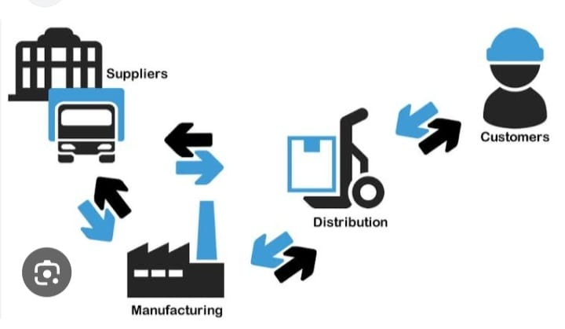

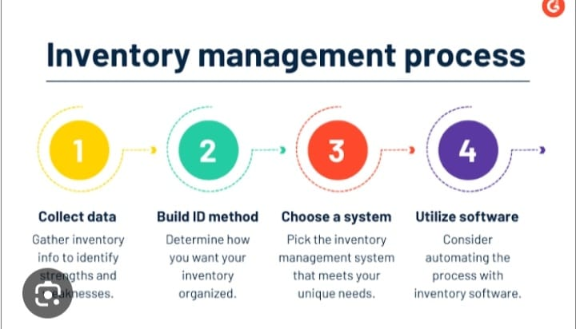

**CHAPTER 4**

**Metrics for Measuring Supply Chain Performance**

**Inventory to sales Ratio:**

**One of the key supply chain metrics on our list, the inventory-to-sales ratio, is critical to track since inventory is crucial to business success. This metric measures the amount of inventory for sale compared to the actual quantity sold, expressed as a ratio.**

**The performance of each components is assessed based on reliability, flexibility, responsiveness, cost, and quality.**

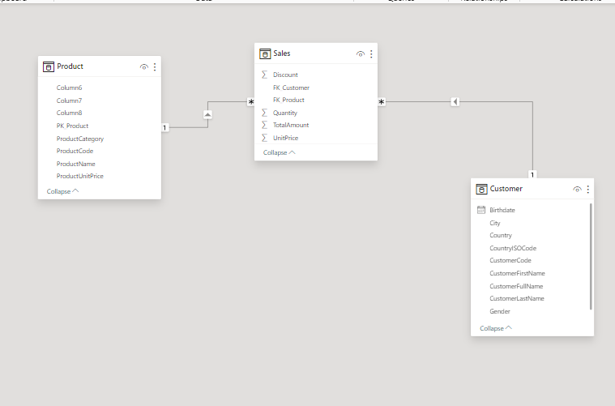

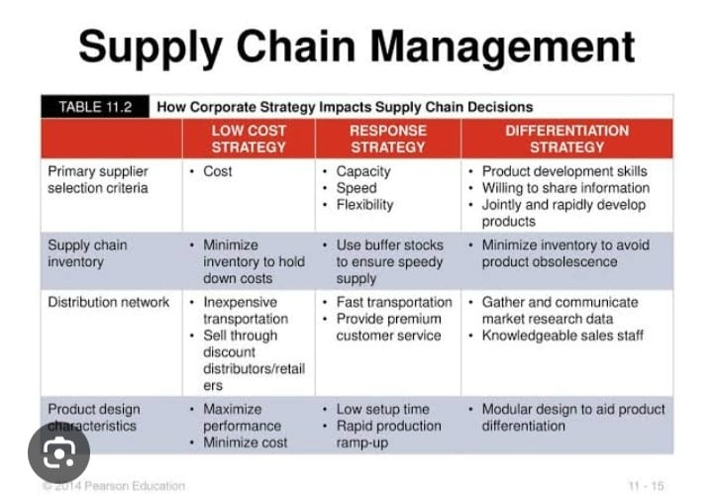

**Dashboard**

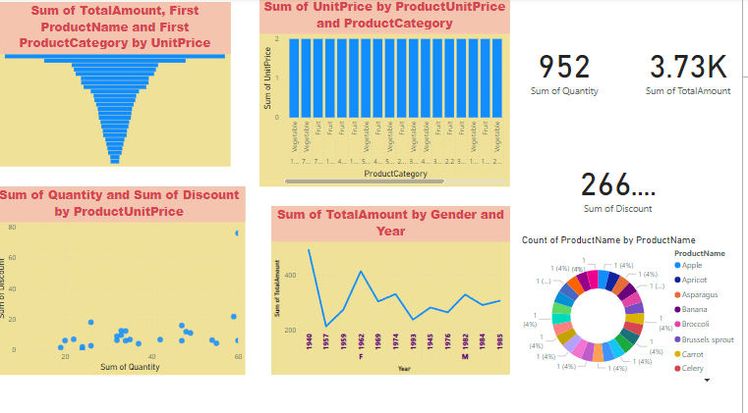

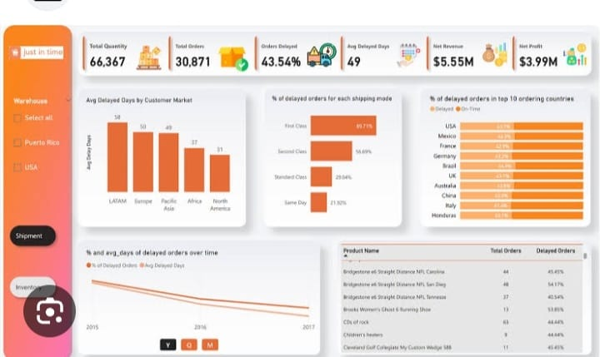

**CONCLUSION**

Inventory management isn’t just about numbers and formulas; it’s about understanding the rhythm and flow of a business. It’s about predicting the unpredictable, preparing for uncertainties, and ensuring that business can meet their commitments to their customers. The difference between a thriving business and one that struggles often lies in how well the business manages its inventories. A well-managed inventory system can lead to increased customer satisfaction, reduced costs, and improved profitability.

**FUTURE SCOPE**

Supply chain management, logistics, and procurement help business stay competitive by helping track and coordinate the cost-effective and efficient movement of goods and service, which is key to the profitability of an organization.

Based on the importance of management of the flow of goods and service vetween locations and business, growth of supply chain management, logistics, and purchasing are on par with average rates and above average.

Therefore, demand professionals skilled in supply in supply chain management, procurement, and logistics roles aren’t likely to dissipate anytime soon.

So, let’s discuss in detail the future scope and opportunities of supply chain management in 2025.

**REFERENCES**

https://researchgate.net/publication/356085653_Inventory_Management_in_Supply_Chains

**LINK**

<https://github.com/githubtraining/hellogitworld.git>